**QUIZ CLUB**  
**BBPS, Noida**  
*(Ob)Serving Knowledge!*

**Q1.** The very first logo of the company was released in the 1960s. The three dots on the logo symbolize the three original locations that were open at the time. As the company planned to add a dot each time a new location opened. Of course, with the incredible success of the company, this plan was scrapped because the logo would otherwise need thousands of dots. Which company’s logos have been talked about here?

**Q2.** Connect: Hootenanny, Take the L, Salt Bae, Ride the pony, The Floss, Gentleman’s Dab

**Q3.** The news on the government radio channels give the date as per the ‘Shaka’ calendar. That’s because this calendar (also called Hindu calendar) is the national calendar of India. What is the first month of this calendar?

**Q4.** This symbol designed by Udaya Kumar D. is inspired from the Hindi (Devnagari) ‘Ra’, and English (Roman) ‘R’. What is it the symbol of?

**Q5.** The picture is of Antonio Guterres. Which post does he hold? 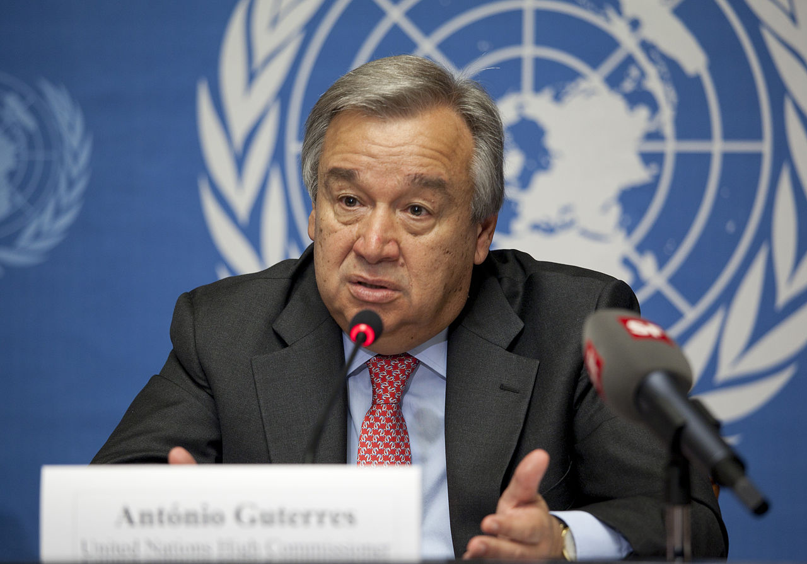

**Q6.** Which American swimmer has a record 28 gold medals in the Olympics?

**Q7.** Ritesh Agarwal founded Oravel Stays as a method for which people can easily book rooms. He then changed its name to ‘X’, which has become one of the most popular startups in the country. It’s logo is a location pin. Identify X.

**Q8.** After being rejected by Twitter and Facebook, Brian Acton founded which popular messaging company valued at more than $17 Billion?

**Q9.** _____ Ravindran cracked the CAT Examination several times but he decided not to join IIM and instead founded his own company which is named after him and is known for using technology to impart education. Identify this company.

**Q10.** The game was created by Kiloo and Sybo. It has Jake as the lead character, who travels through different cities. Name the Game.